**Ideation Phase**

**Empathize & Discover**

|  |  |
| --- | --- |
| Date | 03 August 2025 |
| Team ID | LTVIP2025TMID59168 |
| Project Name | SmartSDLC – AI-Enhanced Software Development Lifecycle |
| Maximum Marks | 4 Marks |

**Empathy Map Canvas** : The Empathy Map Canvas for the SmartSDLC – AI Enhanced Software Development Lifecycle Project is a visual framework that helps the development team deeply understand the users of the platform—primarily software developers, testers, and project managers. By capturing what users say, think, feel, and do, the canvas reveals key insights into their pain points, such as time-consuming documentation, manual bug fixing, and repetitive coding tasks. It also highlights their expectations of streamlined, intelligent tools that can automate and simplify the SDLC process through AI.

This empathy-driven approach ensures that SmartSDLC is built not just with technical efficiency, but also with the users' real-world frustrations and goals in mind.

**Example 1:**

**Empathy Map**

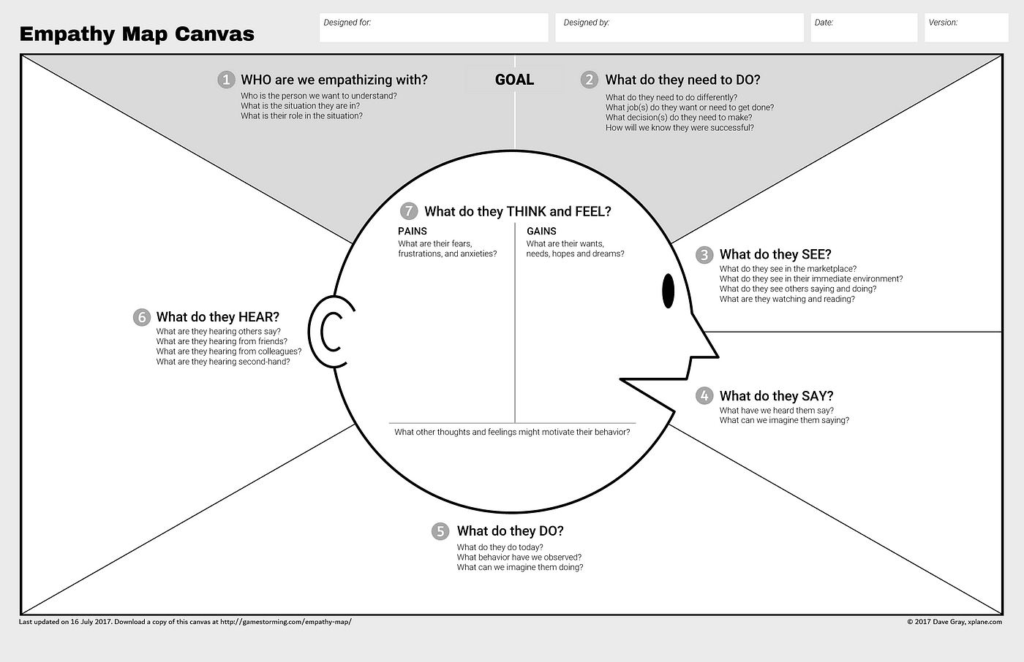

Reference Link : [<https://medium.com/@davegray/updated-empathy-map-canvas-46df22df3c8a>](https://medium.com/@davegray/updated-empathy-map-canvas-46df22df3c8a)

**Example 2:**

